Deliverable IV

**ERD and Alternative Matrix**

**Gym Modernization**

**IS 436: Structured Systems Analysis**

_____________________________________ By: ___________________________________

Alek Babeki

Daniel Cunningham

Jay Early  
Tom Irwin  
Akram Khan

Pratik (PK) Padhiyar

# Section II: Entity Relationship Diagram

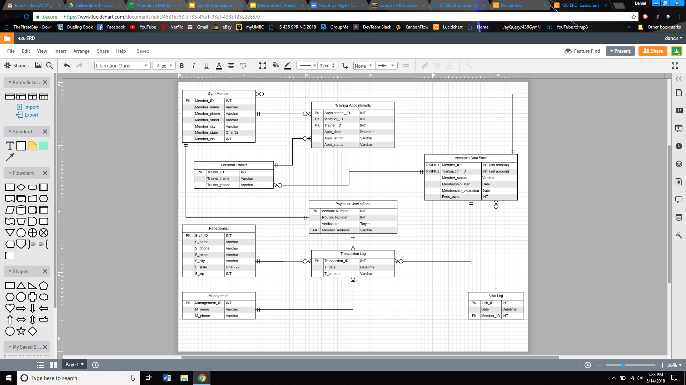

**Gym Member:**

Entity describes a member’s personal information. Connects with Paypal table, accounts table, and appointments table.

**Personal Trainer:**

Entity consists of a trainer’s name and phone. Connected with appointments and accounts table.

**Training Appointments:**

Attributes such as appointment length and status of appointment. Connected to personal trainer and gym member tables.

**Paypal or User’s Bank:**

Contains info such as routing number and member_address. Connected to gym member table.

**Transaction Log:**

Includes a uniquely identified primary key called Transaction_ID along with the actual transaction date & time along with the actual cost amount.

**Receptionist:**

Contains staff personal info as attributes.

**Accounts Data Store:**

Has membership access information including fees owned and start/stop time.

**Visit Log:**

Contains unique primary key called Visit_ID but also includes the actual date and time of the visit itself along with the Member_ID as the foreign key to recognize who actually visited the gym.

**Management:**

Includes Management_ID as primary key along with the management user’s name and phone number.

# Section III: Alternative Matrix

<https://docs.google.com/spreadsheets/d/1E3qMEV6JX0RGeSJApnTgosY1o_bErM8ai-GwbPLC_6o/edit#gid=0>

**Narrative for picking a web application with GCP(alternative one):**

Familiarity with the Google Cloud Platform(GCP) and web development tools such as HTML, CSS, PHP, and Javascript allows us to quickly deploy a web application that suits our gym members needs. Having six team members is ideal for creating this web application as it lets our developers work in tandem with the project manager and business analyst. In addition, to this our developers have experience with Paypal implementation and credit card checks.

In terms of the economic issues, there will be some costs regarding running the Google Cloud software each month and maintaining our scanners, but these should be minimal. The upside to building a web application, is that we can run ads after a set period of time if we need to monetize it. Running a web application for our customers also allows us to build goodwill and understand consumer trends.

Finally, our organizational issues include having a customizable interface that can be updated and tweaked by our developers. These developers can push a feature to the master file in Github allowing seamless integration. Web applications have also been proven to be successful in the marketplace. There is no shortage of websites with logins and ability to make appointments which why it’s vital to provide these features for our clients(gym members). In the future, we like to provide a mobile web application that you can access on your smartphone or tablet, but as for now we only have plans for a website optimized for desktop support.

Nonfunctional Requirements Matrix

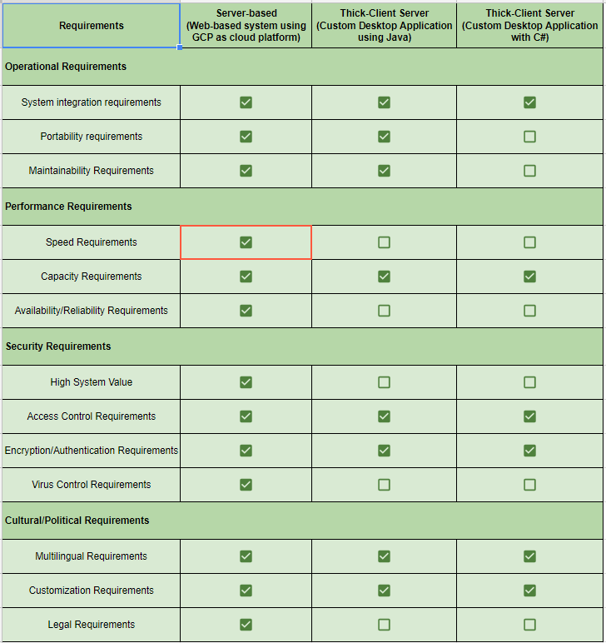

Hardware/Software Spec

